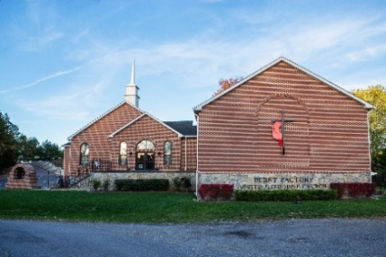
BURNT FACTORY UNITED METHODIST CHURCH
1943 Jordan Springs Road
P O Box 399
Stephenson, VA 22656
540-667-4993
www.burntfactory.org

Nursery Director Position
$7,500.00 annually. Average 8-10 hours a week.
Ministry Purpose:
To provide safe, secure, nurturing, clean and efficient care to our children while following the Safe Sanctuaries policies set by the Virginia Annual Conference of the United Methodist Church.
Early childhood is the best time to build a God-centered worldview for children.
Basic functions:
- Scheduling staff in the nursery and ensuring proper coverage that follows the Safe Sanctuaries guidelines.
- Training of new hires and volunteers in the nursery area.
- Work with the Minister of Children and Family to establish & implement policies and procedures in the nursery.
- Responsible for implementing policies and procedures.
- Manage intake/outtake of children on Sunday services and any special or evening services with the current check-in system.
- Engage with children in the nursery through crafts, music, games and stories to teach the children basic Christian fundamentals.
- Manage staff/volunteer time with the children during services.
- Rotation, organization and cleansing of classroom, toys, furniture and other nursery items.
- Communicate supply needs to Minister of Children and Family.
- Report any personnel issues to Minister of Children and Family.
- Issuing of paperwork to new families/visitors.
- Management & organization of curriculum & nursery files.
- Appropriate care of children including diaper changes and feedings if necessary.
- Maintain adequate supplies & inventory for the nursery & children’s Ministry activities.
- Procure supplies & materials for the nursery & for teachers.
- Assist with planning and set up of child activities (ie: Church picnic, VBS, family fall fun festival, Christmas play, evening services, Easter activities and egg hunt). This includes purchasing of supplies for events, gathering of volunteers and set up/clean up.
- Coordinate volunteer gifts on 5th Sundays and larger events (VBS, Camp, Christmas play).
- Provide assistance to Minister of Children and Family when needed.
Additional Functions:
- Ensure that only nursery staff and approved volunteers are permitted in the nursery classrooms.
- Visitors to the nursery classrooms need to be limited to parents and guardians of children who wish to tour the nursery rooms for potential care.
- All volunteers/substitutes need to be approved by the Minister of Children and Family.
- Working alongside parents to ensure the best teaching/learning opportunities.
- Praying for and with the children

