THIS WEEK | LOOKING AHEAD
Tuesday, February 25  Noon BLT  5:30 Praise Team Sanctuary  6:30 Choir Practice Sanctuary  Wednesday, February 26  9-12 Pastor’s Office Hours | March  CCAP Collection Easter Food  March 2  Transfiguration Sunday  1:30-3:30 Choir Cantata Practice  March 3  7pm Handyman Team
THE MINISTRY
Ministers……………………………………………………. Every Member
Pastor…………………………………………. Pastor C. Steven Melester
Lay Leader…….………………………………………..….....…. Jani Shope
Minister of Children and Administration…..…...……………… Carrie Fair
Minister of Youth………………………………………...……Erin Hartman
Worship Leader……………………Erin Hartman, Joy Melvin, Tom Miiller
Minister of Music…………......…………………………...….. Diana Smith
Pianist.………………………………………………………David Bilowus
Parish Faith Community Nurse………………………..……Theresa Gilbert
Audio/ Visual System…………….Sam Lentz, James Perkins, Harrison Fair
Nursery Directors……………………Emma McKinley & Addison Russell
Nursery Staff…………………….Lisa Holmes, Kylie Eaton, Lucas Meeks

EMAIL ADDRESSES
Pastor Steve Melester……………..……pastor@burntfactory.org
Carrie Fair……………………….…..... admin@burntfactory.org
Erin Hartman………………………..…..youth@burntfactory.org

Attendance 2/16/25
8:30- 88 11:00-128 Streaming- ES: 45 LS: 69

Offering 2/16/25
$9,503.00

Burnt Factory Church

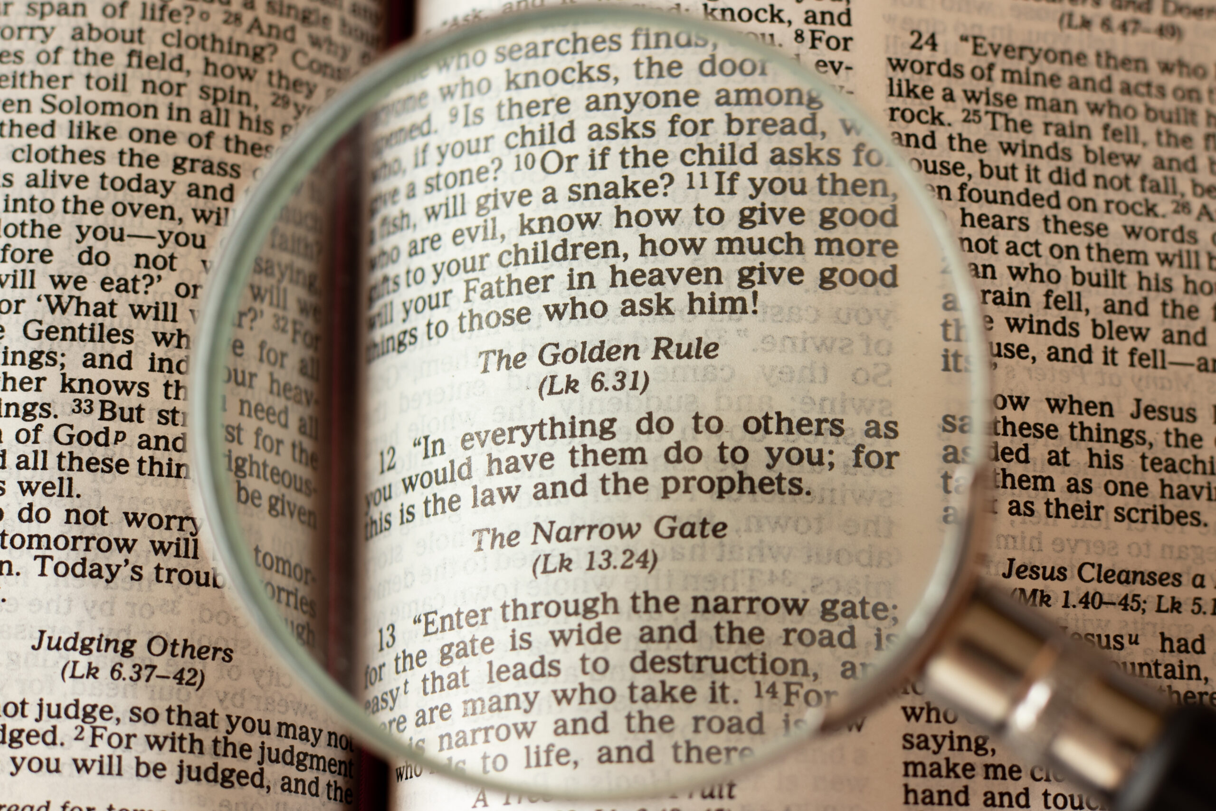
A Good Measure

Sharing the Love of Christ with All People

1943 Jordan Springs Road (P O Box 399)
Stephenson, VA 22656
540-667-4993
www.burntfactory.org

Service of Word
Seventh Sunday after the Epiphany
February 23, 2025

WE GATHER IN GOD’S PRECIOUS NAME
At Burnt Factory Church, we believe that the gathering of God’s people for worship is a time of great joy and celebration! We are to enter his gates with thanksgiving and praise!
“This is the day that the Lord has made, let us rejoice and be glad in it!”
GATHERING MUSIC
WELCOME AND GREETING
ANNOUNCEMENTS
OPENING PRAYER

WE PRAISE GOD FOR OUR CHILDREN
“Jesus said, “Let the little children come to me, and do not hinder them, for the kingdom of heaven belongs to such as these.” Matthew 19:14
Jesus loves me! This I know, for the Bible tells me so, little ones to him belong, they are weak, but he is strong. Yes, Jesus loves me! Yes, Jesus loves me!
Yes, Jesus loves me! The bible tells me so!
(Infants and toddlers may go to the nursery after the message and children in grades 1-5 may go to Children’s Church)

*CALL TO WORSHIP “The Apostle’s Creed”
I believe in God the Father Almighty, maker of heaven and earth. And in Jesus Christ his only Son our Lord; who was conceived by the Holy Spirit, born of the Virgin Mary, suffered under Pontius Pilate, was crucified, dead, and buried; the third day he rose from the dead; he ascended into heaven, and sitteth at the right hand of God the Father Almighty; from thence he shall come to judge the quick and the dead. I believe in the Holy Spirit, the holy catholic¹ church, the communion of saints, the forgiveness of sins, the resurrection of the body, and the life everlasting. Amen. (¹universal)

*OPENING HYMN “Freely, Freely” #389

WE PRAISE GOD THROUGH THE READING OF THE HOLY SCRIPTURES
Lesson Luke 6: 27-31

WE PRAISE GOD THROUGH MUSIC
8:30 Mike Dick “Take My Hand, Precious Lord”
11:00 Chancel Choir “ That Wondrous Cross”

*PASSING OF THE PEACE

WE PRAISE GOD THROUGH THE PROCLAMATION OF THE WORD
Sermon “ The Golden Rule Says It All ”
Pastor Steve
Luke 6: 35-38

*HYMN OF RESPONSE “Take My Life and Let it Be” #399

WE PRAISE GOD THROUGH PRAYER

LORD’S PRAYER

*HYMN OF GOING FORTH
“Blessed Assurance” #369

*BLESSING AND BENEDICTION
“Go and make disciples of all nations, baptizing them in the name of the Father, Son and Holy Spirit, and teaching them to obey everything I have commanded you. And surely, I am with you always, to the very end of the age.”
Matthew 28: 19-20

*You are invited to stand as you are able

